YEAR 12 PHYSICS

SEMESTER TWO EXAMINATION 2005

Name: _________________________

Teacher: _______________________
(Questions marked with a * are for the pre 2010 course)
(Stars have not been placed in the answer key only in the blank question paper)

TIME ALLOWED FOR THIS PAPER

Reading time before commencing work: Ten minutes
Working time for paper: Three hours

MATERIAL REQUIRED/RECOMMENDED FOR THIS PAPER

TO BE PROVIDED BY THE SUPERVISOR

This Question/Answer Booklet
Physics Formulae and Constants Sheet

TO BE PROVIDED BY THE CANDIDATE

Standard Items: Pens, pencil, eraser, correction fluid and ruler

Special Items: Drawing instruments, templates and calculators satisfying the conditions set by the Curriculum Council.

IMPORTANT NOTE TO CANDIDATES

No other items may be taken into the examination room.

It is your responsibility to ensure that you do not have any unauthorised notes or other items of a non-personal nature in the examination room. If you have any unauthorised material with you hand it to the supervisor BEFORE reading any further.

STRUCTURE OF PAPER

Section | No. of questions | No. of questions to be attempted | No. of marks out of 200 | Proportion of examination total
A: Short Answers | 15 | ALL | 60 | 30%
B: Problem Solving | 6 | ALL | 100 | 50%
C: Comprehension and Interpretation | 2 | ALL | 40 | 20%

INSTRUCTIONS TO CANDIDATES

Write your answers in the spaces provided beneath each question. The value of each question (out of 200) is shown following each question.

The Physics Data Sheet must also be submitted with your exam.

Calculators satisfying the conditions set by the Curriculum Council may be used to evaluate numerical answers.

Answers to questions involving calculations should be evaluated and given in decimal form. Quote the final answer to no more than three significant figures. Despite an incorrect final result, credit may be obtained for method and working, provided these are clearly and legibly set out.

Questions containing specific instructions to show working should be answered with a complete, logical, clear sequence of reasoning showing how the final answer was arrived at; correct answers which do not show full working will not be awarded full marks.

Questions containing the instruction estimate may give insufficient numerical data for their solution. Students should provide appropriate figures to enable an approximate solution to be obtained.

SECTION A: Short Answers

Marks Allotted: 60 marks out of total of 200 marks (30%)

Attempt ALL 15 questions in this section. Each question is worth 4 marks. Answers are to be written in the space below or next to each question.
_____________________________________________________________________

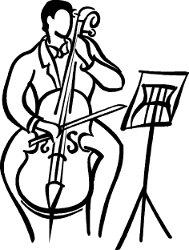
1. The Cello is a stringed instrument, belonging to the violin family. The first string plays a note of fundamental frequency 65.4 Hz.

a) Comment on the pitch of the sound from the first string and its potential to be diffracted through doorways.
b) Estimate the speed of the wave travelling in the first string when the fundamental note is being played. State any assumptions that you make.

2. Tom’s toy cannon propels a matchstick at 1.5 m s⁻¹ at an angle of 32º to the horizontal. Ignoring the effects of air resistance, find the horizontal distance (range) covered by the matchstick. State any assumptions that you make.
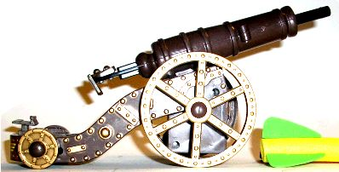
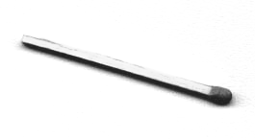

3. The figures below show sketches of two different types of crane. Which crane
is more stable when fully loaded? Justify your answer.

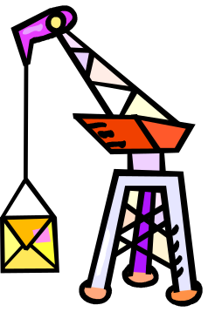
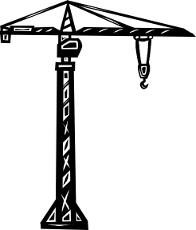
Crane ACrane B

4. The figure below shows two different trajectories of a cricket ball.

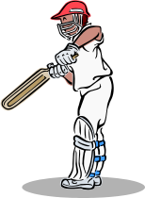

Tick any of the following properties that are different for the two trajectories. You should ignore the effects of air resistance.

- Time of flight
- Initial velocity
- Net force during flight
- Net acceleration during flight
- Final (impact) velocity
- Final horizontal displacement
- Final vertical displacement
5. Some minerals such as fluorite; fluoresce under ultraviolet light. Explain what is meant by fluorescence.

6. The diagram represents a tube open at both ends, supporting a standing wave.
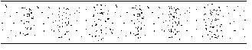
75.0 cm

a) What harmonic is represented by the diagram?
b) What is the frequency of the standing wave represented?

7. Emma struck a tuning fork and recorded the sound on her cassette player. When she played back the recorded sound she noticed that the tuning fork was making a sound, as well as the cassette. Explain this observation.




8. Hamish’s toy car set has a loop-the-loop, as shown in the diagram below. Estimate the minimum speed that a toy car should have at the top of the loop to be able to successfully complete the loop-the-loop without dropping off the track. State any assumptions that you have made.
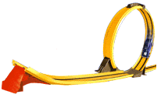

9. The new saltwater desalination plant in Kwinana will consume an average of
80 kW of electrical power. The plant will operate at a voltage 450 V.
a) What average current will the plant draw?

b) The plant will be connected to the Western Power Supergrid, that supplies electrical energy at 130 kV. Determine the ‘turns ratio’ of the transformer that will be required at the desalination plant to provide the 450 V.

10. A sodium lamp emits yellow light; that to the human eye appears to be quite similar to a candle flame in colour. When light from these two sources is viewed through a spectroscope, it is found that their spectra are very different. Explain the differences in the two spectra produced.
11. A claw hammer is not only used to hit nails into wood, it can be used to remove them. The figure shows a close-up of a claw hammer as it pulls a nail out of a horizontal piece of wood. A 120 N force is exerted at the end of the hammer perpendicular to the handle (not shown).

a) Estimate the force exerted by the claws of the hammer on the nail. List any
assumptions that you make.
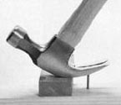

b) Placing the hammer on a small piece of wood is a handy hint that many carpenters know. Explain why this technique would make the removal of a nail easier.

*12. A mild steel spike of length 33 cm and radius 0.5 cm is struck by a large hammer which exerts a force of 120 kN. If the spike did not move, by how much did its length contract during the impact?

13. Suppose you have two iron bars that look identical. One is a magnet and the other is an ordinary iron bar. By not using anything else besides these two bars, what could you do to tell which was the magnet? Note: You are only permitted to observe interactions between the two bars.

14. The diagram shows the inner workings of a simple galvanometer that measures small currents.
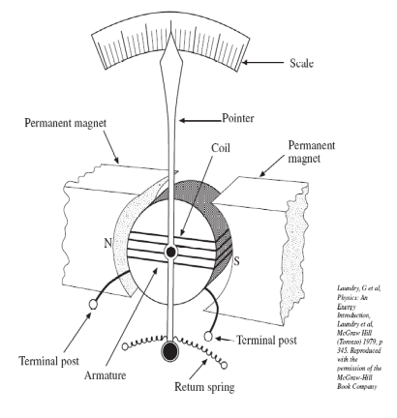
a) Which type of current, AC or DC is this meter
suitable for? Explain.

b) Using the motor effect, explain briefly how this meter operates.

15. If you were to expose some photographic film to the light from various stars, their ‘true’ colours can be observed. We generally can’t see the true colours of stars as our eyes are not sensitive enough.

Using this technique, some stars appear to be more red than others and some appear to be more blue than others. Which stars would have the hottest surface temperature? Explain.

END OF SECTION A
SECTION B: Problem Solving

Marks Allotted: 100 marks out of total of 200 marks (50%)

This section contains 6 questions. You should answer ALL of the questions and show full working. Unless otherwise indicated, all answers should be evaluated to 3 significant figures.

Answer all questions in the spaces provided.
_____________________________________________________________________

1. [19 marks]
A mobile crane is being used to position a very heavy pot plant of mass 225 kg. The crane’s boom is uniform, 5.50 m long and has a mass of 125 kg. The boom is supported by a hydraulic ram, attached 2.50 m from the point about which the boom pivots.
- The pot plant is supported by 2 small cables of equal length. There is an angle of 60.0º between the two small cables at the point at which they are attached to the main cable. Find the tension in each of the smaller cables.
[2 marks]
4.50 m
2.50 m
30 º
5.5 m
225 kg
60 º
HYDRAULIC
RAM
70 º
2.5 m
BOOM
PIVOT
Front
Back
- For the position shown, find the size of the force provided by the hydraulic ram on the boom.
[3 marks]

- If the mobile crane has a mass of 5.60 tonne and its centre of mass acts along a line located 75.0 cm behind the front wheels, find the maximum load (in kg) that the mobile crane could lift without toppling.
[6 marks]

d) Describe three methods of increasing the lifting capacity of the crane, without increasing its mass. Explain the Physics behind each method.
[3 marks]

e)* If the main cable attached to the boom is made from mild steel. What minimum diameter would it need to have for it not to break when supporting the load calculated in part (c)?
[3 marks]

f) If the mobile crane was being used on Mars (which has less gravity than Earth), how would this have affected your answers to part (c) and (e)? Explain your answer.
Note: no calculation is required.
[2 marks]
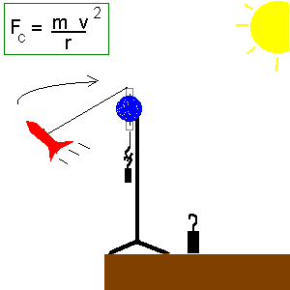
2. [16 marks]
a) Eloise is experimenting with a toy rocket attached to a nylon line, which is threaded through a polished glass tube and is attached to a weight. The glass tube is mounted to the top of a retort stand as shown in the diagram. The rocket is ‘self-propelled’ and travels in a horizontal circular path at a constant speed.

For one particular experiment, Eloise was using a nylon thread that measured exactly 33.0 cm from the top of the glass rod to the rocket and the experiment required a 150 gram mass attached to the end of the nylon thread. The thread made an angle of 15º with the horizontal. The diagram below represents the rear view of the rocket at this time.

i) Show with arrows, all forces acting on the rocket. Show clearly, the ‘net force’ acting on the rocket – preferably in a different colour.
[3 marks]
15º
33 cm

ii) Find the mass of the rocket.
[3 marks]

iii) Find the speed of the rocket.
[3 marks]

iv) If this experiment had been performed on a planet with more gravity than the Earth, would the length of thread from the glass tube to the rocket been longer or shorter, given the same velocity and angle? Explain.
[2 marks]

b) The rocket has a small LED (light emitting diode) that emits light with a range of wavelengths, although 99.9% of its power is emitted as 514 nm light.
i) Calculate the energy of one of the 514 nm photons emitted.
[2 marks]

ii) A typical LED has a power rating of 1.33 W. How many 514 nm photons are emitted each second?
[2 marks]

iii) An argon ion laser also emits 514 nm light. The diagram below shows some possible energy levels of an argon ion. Indicate the electron transition responsible for the emission of the 514 nm light. [1 mark]
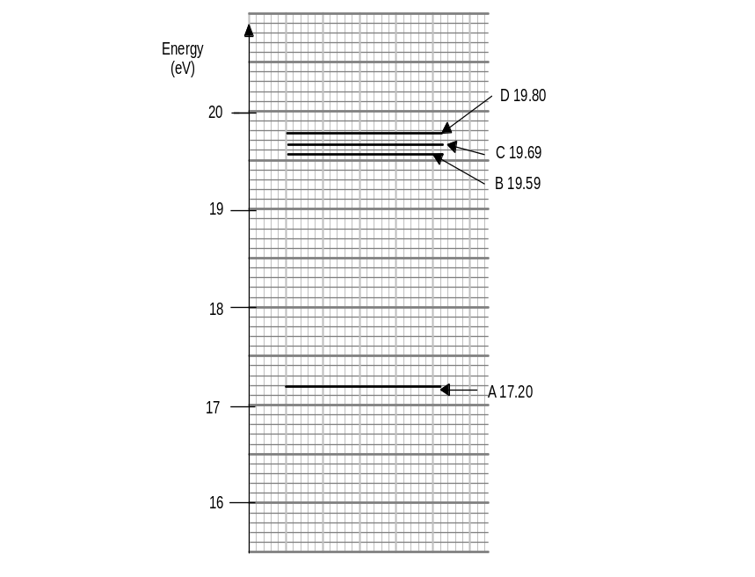
3. [16 marks]
a) A metal axle from a model railway train is propelled along two live rails as shown in the diagram below.

i) For the axle to move in the direction shown, a magnetic field of intensity of
4.0 x 10⁻² T is applied. Circle the direction/letter next to the arrow that indicates the direction of the magnetic field.
[2 marks]

A
B
C
D
E
F
Direction of propulsion
+
-

ii) The axle has a mass of 55 g and has a length of 4.0 cm. Find its acceleration if the current through the axle is 16.0 A.

[3 marks]
iii) In fact, the acceleration is somewhat less than that calculated in part (iii). Suggest reasons for this.

[2 marks]

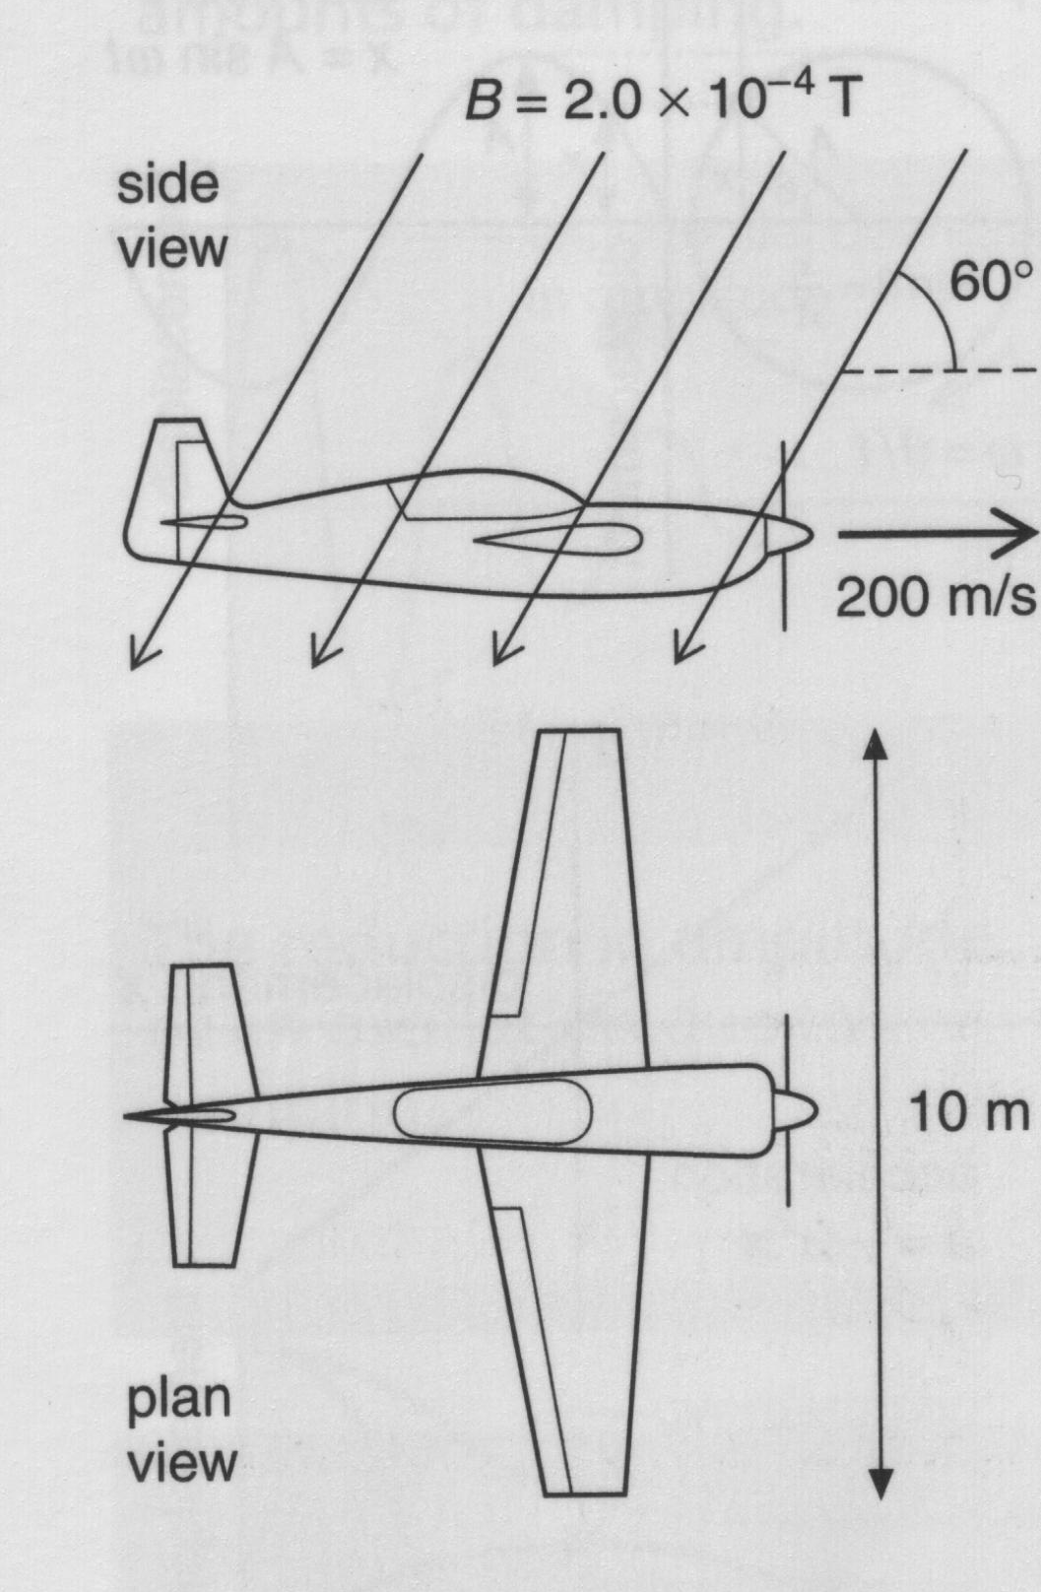
b) An aeroplane with a wingspan of 10.0 m is flying horizontally at a velocity of 200 m s⁻¹. In the region the plane is flying, the Earth’s magnetic field is
2.0 x 10⁻⁴ T, at an angle of 60º to the horizontal.

i) Which component (horizontal or vertical) of the Earth’s magnetic field is used to calculate emf across the wings?

[1 mark]
ii) Find the size of this component of the field.

[2 marks]

iii) What emf is induced across the wingtips of the plane?

[2 marks]

iv) Could this emf be used to power the cabin lights? Explain.

[2 marks]

v) The aeroplane then does a ‘loop-the-loop’. Sketch a graph of the emf induced as a function of the angle with which the plane is flying to the horizontal.

[3 marks]

4. [13 marks]
a) Hannah is watching her favourite TV show (Rage) while listening to the sound through her stereo. Her stereo system has a speaker separation of 3.0 m and she is sitting on her sofa 8.0 m from the wall on which the speakers are mounted (at head height). Once her show has finished (at 5 in the morning!), the TV station emits a constant tone whilst displaying a blank screen. Hannah notices that when she is sitting in the middle of her sofa, the sound is quite loud, but when she moves her head 35 cm to either side, the sound becomes quite soft.
3.0 m
8.0 m

i) Explain this observation.

[2 marks]

ii) Using the information provided, determine the frequency of the sound emitted.

[6 marks]
iii) If Hannah walked toward the television along a line equidistant from each speaker (shown as a dashed line), what would she hear?

[2 marks]

iv) Stereo speakers are supposed to be ‘phased’ when they are set up. That is, the waves emitted from them should be in phase with each other. If one of the speakers had been wired up backwards, that is, out of phase with the other, how would this have affected Hannah’s observations described at the beginning of this question?

[3 marks]

5. [19 marks]
It is 2015 and the Human Race has finally reached Saturn. Because Saturn is gaseous, the exploration team decide to land on Titan, one of Saturn’s moons, via a small landing craft. The table below contains various facts about Titan and its orbit about Saturn.

Titan Statistics
Discovered by | Christiaan Huygens
Date of discovery | 1655
Mass (kg) | 1.35 x 10²³
Radius (km) | 2,575
Mean distance from Saturn (km)  (centre to centre) | 1,221,850
Rotational period (Earth days) | 15.94542
Orbital period about Saturn (Earth days) | 15.94542
Mean orbital velocity (km/sec) | 5.57
Atmosphere | none

a) From the data in the table and your data sheet, determine:

i) The gravitational field strength (g) on the surface of Titan.

[2 marks]
ii) The mass of Saturn
[4 marks]
b) Gemma who is the astronaut controlling the main spaceship, wants to remain above the same position on Titan’s surface to maintain radio contact with the landing craft and the astronauts who land on the surface. At what altitude above Titan’s surface will she need to position the spaceship to hold the required geostationary orbit?

[5 marks]

c) Later in the day, Greg, one of the astronauts who lands on Titan, has a small accident and realises that he has left his first aid kit on the main spaceship. He asks Gemma to come in low and drop off the first aid kit.

i) To save on fuel, Gemma decides to orbit Titan with an altitude of 250 m to drop off the first aid kit. This is just high enough to not collide with any mountains. How fast will the spaceship be travelling whilst in this low orbit?

[2 marks]

ii) Would it be practical for Gemma to use this technique to drop the kit to Greg? Explain.

[2 marks]

iii) Why would maintaining a low stable orbit at this speed save on fuel compared
to travelling at slower speed to drop off the kit?

[2 marks]

iv) Would it be possible to position a spaceship at such a low orbit above Earth, even if there were no mountains in the way? Explain.

[2 marks]

6. [17 marks]
a) A thin metal plate is attached to a wooden rod which is pivoted as shown in the diagram. Indra allows it to swing freely at an initial angle of 41º to the horizontal.

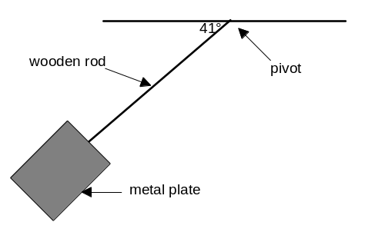

She found that once the plate swung to the other side, it made a similar angle to the horizontal.

She then immerses the apparatus in a uniform magnetic field of 5.0 mT into the page as shown in the diagram below.

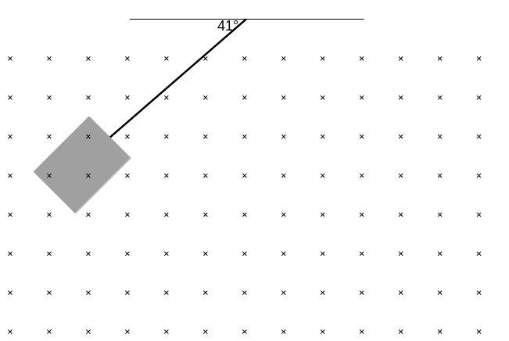

i) Estimate the angle that the rod would make with the horizontal after swinging from one side to the other in the field. Explain how you arrived at your estimate.

[2 marks]

ii) She repeats the experiment, this time reversing the magnetic field when the rod is at the vertical position. How would this affect the final angle that the rod makes with the horizontal? Explain

[2 marks]

iii) If the metal plate was shaped as illustrated in the diagram below, how would this have affected your answers to (i) and (ii) above? Explain.



[3 marks]

b) The buzzing sound emitted by a mosquito has a frequency of approximately
1000 Hz. At a distance of 10 metres, the sound of one mosquito is at the threshold of human hearing.

i) What is the intensity of sound at the threshold of human hearing?

[1 mark]

ii) What is the ‘acoustical power’ of the single mosquito? What assumptions have you made?

[3 marks]
*iii) What is the intensity and intensity level (in dB) when the mosquito is 10.0 cm from a person’s ear?

[3 marks]

*iv) How many identical mosquitoes would there have to be at a distance of 10.0 m to sound as loud as one mosquito at a distance of 10.0 cm?

[3 marks]

END OF SECTION B
SECTION C: Comprehension and Interpretation [40 Marks]

BOTH questions should be attempted.
Read the following passages and answer the questions at the end of each. Candidates are reminded of the need for clear and concise presentation of answers. Diagrams (sketches), equations and/or numerical results should be included as appropriate.

1. Sticky Spider Webs by Dr Karl Kruszelnicki
Text Taken from Breakthrough – Creativity and Progress in Science. The Science Foundation for Physics, The University of Sydney, 1995.

Sticky Spiders Web
Paragraph 1
In a horror movie, one of the worst things that can happen is to run your face into a spider’s web. But not all of the spider web is sticky — just bits of it. A spider’s web catching a fast-flying insect is like a tennis net catching an F-18. How does it catch insects, without breaking?
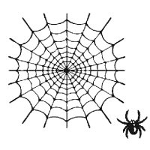
Radial threads
Spiral threads
Figure 1: Radial and Spiral threads of a spider web.
Paragraph 2
Understanding how the spider’s web works, is a good example of a breakthrough that depended only on someone having a good look with a simple microscope. There’s an old saying in medicine — “If you don’t take a temperature, you won’t find a fever”. And in science, if you don’t look, you won’t find.

Paragraph 3
Unfortunately for spiders, they are so hated and feared by humans, that we had to invent a special disease — Arachnaphobia. But practically all spiders are harmless to humans. In fact, spiders do the human race a great service by catching and eating billions of insects every day. There are at least 30,000 different species of spiders, but only 2,500 of them make a web. And it was only in the late 80’s that scientists discovered how the web really works.

Paragraph 4
Spiders evolved shortly after the first insects appeared, about 370 million years ago. The spiders very rapidly developed fangs and venom glands loaded with some very fancy drugs. Practically all the spider venoms act like nerve gas, scrambling the nervous system of their prey. But as the spiders evolved, they invented the web.

Paragraph 5
Some modern tricky spiders have gone high-tech. Not only are their webs thin and sticky, but to an insect, they glow whiter than white, and in fact, they look like a sexy plant.

Paragraph 6
We humans can’t see ultra-violet light, but insects can. Many flowers have patterns of ultra-violet reflection, near where the pollen and nectar are. This pattern spells FOOD to insects. Some of the spiders that make long-term webs (the ones that they leave up for days at a time) have added a chemical to their webs to make them reflect ultra-violet light in the same pattern that the flowers use. And it works really well — these glowing spider webs capture 60% more insects than the ordinary non-fluorescent types.

Paragraph 7
Now you might think that all the strands in a spider web are the same, but there are two different types, stretchy ones, and not-so-stretchy ones. When the garden cross spider, Araneus diadematus makes its web, it extrudes only one type of thread. But depending on where the thread will be used, it either puts a coating on it, or it doesn’t. This coating radically changes the properties of the thread.

Paragraph 8
First there are the uncoated radial strands, like the spokes of a bicycle, which all radiate out from a common centre. These strands are very stiff, and will only stretch by about 20% before they snap. The other strands are the coated sticky spiral capture strands, which go round and round from the centre like the groove of an old-fashioned LP record. These spiral capture threads can stretch up to 200% of their original length, and then contract again into a tight spiral, without sagging.

Paragraph 9
These spiral threads are called “Capture Threads”, because they’re made sticky with a thick watery glue that is 80% water, and 20% amino acids, fats and salts. This glue is extruded at the same time as the thread, from the back end of the spider. It comes out as a cylinder of sticky liquid, but it immediately bunches up on the thread into a series of evenly spaced droplets about 100 microns apart. That spacing is a little bit more than the thickness of a human hair. But as these droplets of glue begin to globulate, they act like tiny winches, and they wind up balls of loose spider web thread inside them, and keep the web nice and tight.

Paragraph 10
So when you try to stretch the threads of the capture spiral, the extra loops of thread inside these droplets of glue unwind — and when you take the load off the thread, they spring back and coil up inside the drops of glue again.

Paragraph 11
This research was done by 2 scientists at the University of Oxford — Fritz Vollrath, a zoologist and Donald Edmonds, a physicist. They reckon that having stiff radial threads and elastic spiral threads woven into a single web gives it the ultimate design.

Paragraph 12
The non-sticky stiff radial threads provide the basic structure to the spider web. They let the spider move around on the web without getting stuck, and let the spider know when something is caught in the web by transmitting the vibrations of the prey as it wriggles around.

Paragraph 13
The sticky glue-coated elastic spiral capture threads can maintain the tension whether they’re stretched or contracted. Because the threads are elastic, they tend not to touch each other when the web is pushed around in a strong wind. These elastic properties are very handy for absorbing the energy of a fast flying insect, for helping the insect entangle itself in the sticky web, and finally, for not giving the struggling insect a solid footing which might help it escape.

Paragraph 14
The spiders have evolved a brilliant design for their web. And by coating the right parts of their non-tangled web with a high technology glue, they’re able to stretch their net beyond the limits of insect technology.

Paragraph 15
High-school students could have made this discovery about spider webs — but they didn’t. There’s an old saying “It’s not the answer that gets you the Nobel Prize, it’s the question”. Curiosity leads to breakthroughs.
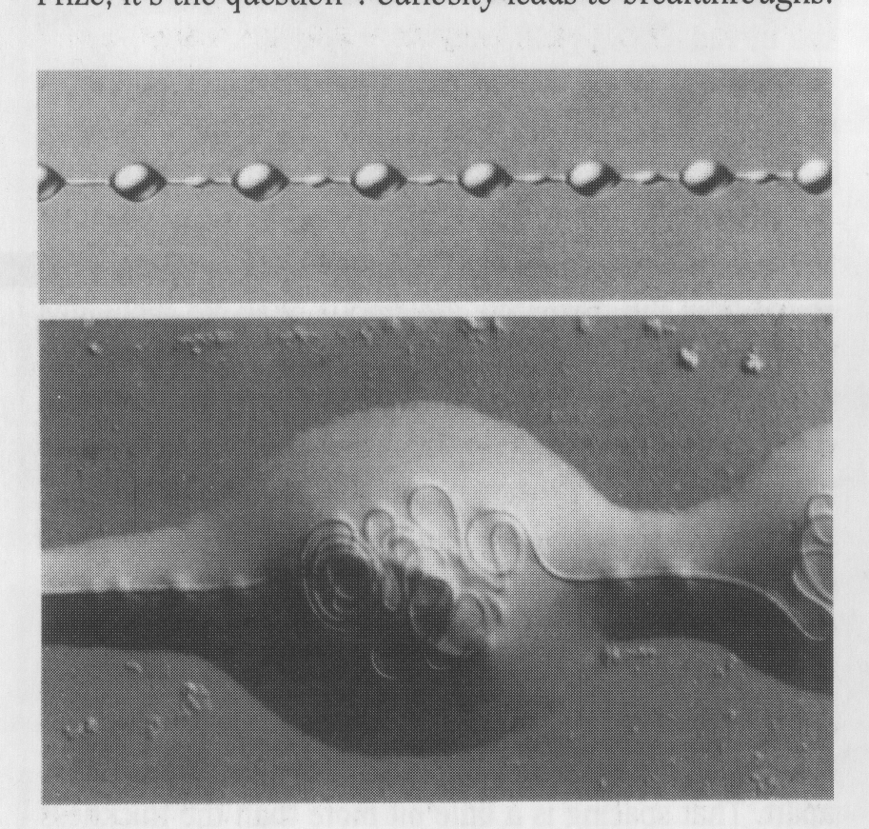
Figure 2. Capture Thread of an ecribellate spider, such as A. diadematus, is covered with an aqueous coat, shown magnified 100 times. Surface tension within each drop causes the core fibres to bunch up, creating a windlass system, shown here in its contracted state (bottom), magnified 300 times.
(Scientific American, March 2002)

Questions
1. The Passage discusses fluorescence in paragraphs 5 and 6. Is the process described in the article actually fluorescence? Explain.

[4 marks]

*2. Explain briefly why the radial threads behave stiffer than the spiral threads of a spider web (Paragraphs 8-10).
[4 marks]

*3. Which threads are the most responsible for letting a spider know that there is something caught in its web? (paragraph 12). Using your knowledge of Physics, explain why one type of thread is better than the other for this purpose.
[4 marks]

*4. Using the information contained in the article, complete the following table. Use an ‘R’ for radial threads and an ‘S’ for spiral threads. The first one is done for you.

Property | Type of thread (R or S)
Made sticky with a watery glue | S
Stiffest
Most elastic
Lowest Young’s Modulus value
Best at transmitting vibrations
[4 marks]

*5. The following data is for the thread from the spider: Nephila clavipes.

Young’s Modulus | 22 GPa
Ultimate Tensile Strength | 1.1 GPa
Ultimate Tensile Strain | 19%
* Note: Ultimate Strength and Strain refer to the breaking point.

Was the thread behaving elastically or plastically at the moment of fracture? Explain.
[4 marks]

2. The Cyclotron
– Article adapted from the website of Stanford University. (http://www2.slac.stanford.edu/vvc/accelerators/circular.html) and Applciations for Senior Secondary Physics, South Australian Science Teachers Association.

Paragraph 1
A cyclotron is a device for accelerating charged particles to high energies, generally for the purpose of allowing them to collide with atomic nuclei in a target to cause a nuclear reaction. Many present day cyclotrons are located in hospitals, where the nuclear reactions produce short-lived radioactive pharmaceuticals for use in medical diagnosis or treatment.

This article describes some of the Physics behind the operation of a cyclotron.

Paragraph 2
To understand how a cyclotron works, first you have to understand two basic points about electric and magnetic fields and their effects on charged particles.
- When a charged particle is in an electric field it feels a force that accelerates it in the direction of the field (or in the direction opposite to that direction if it is a negatively charged particle). If this force is in the direction that the particle is already traveling then clearly this acceleration speeds up its motion and thus adds energy (and this is what we want our accelerator to do).
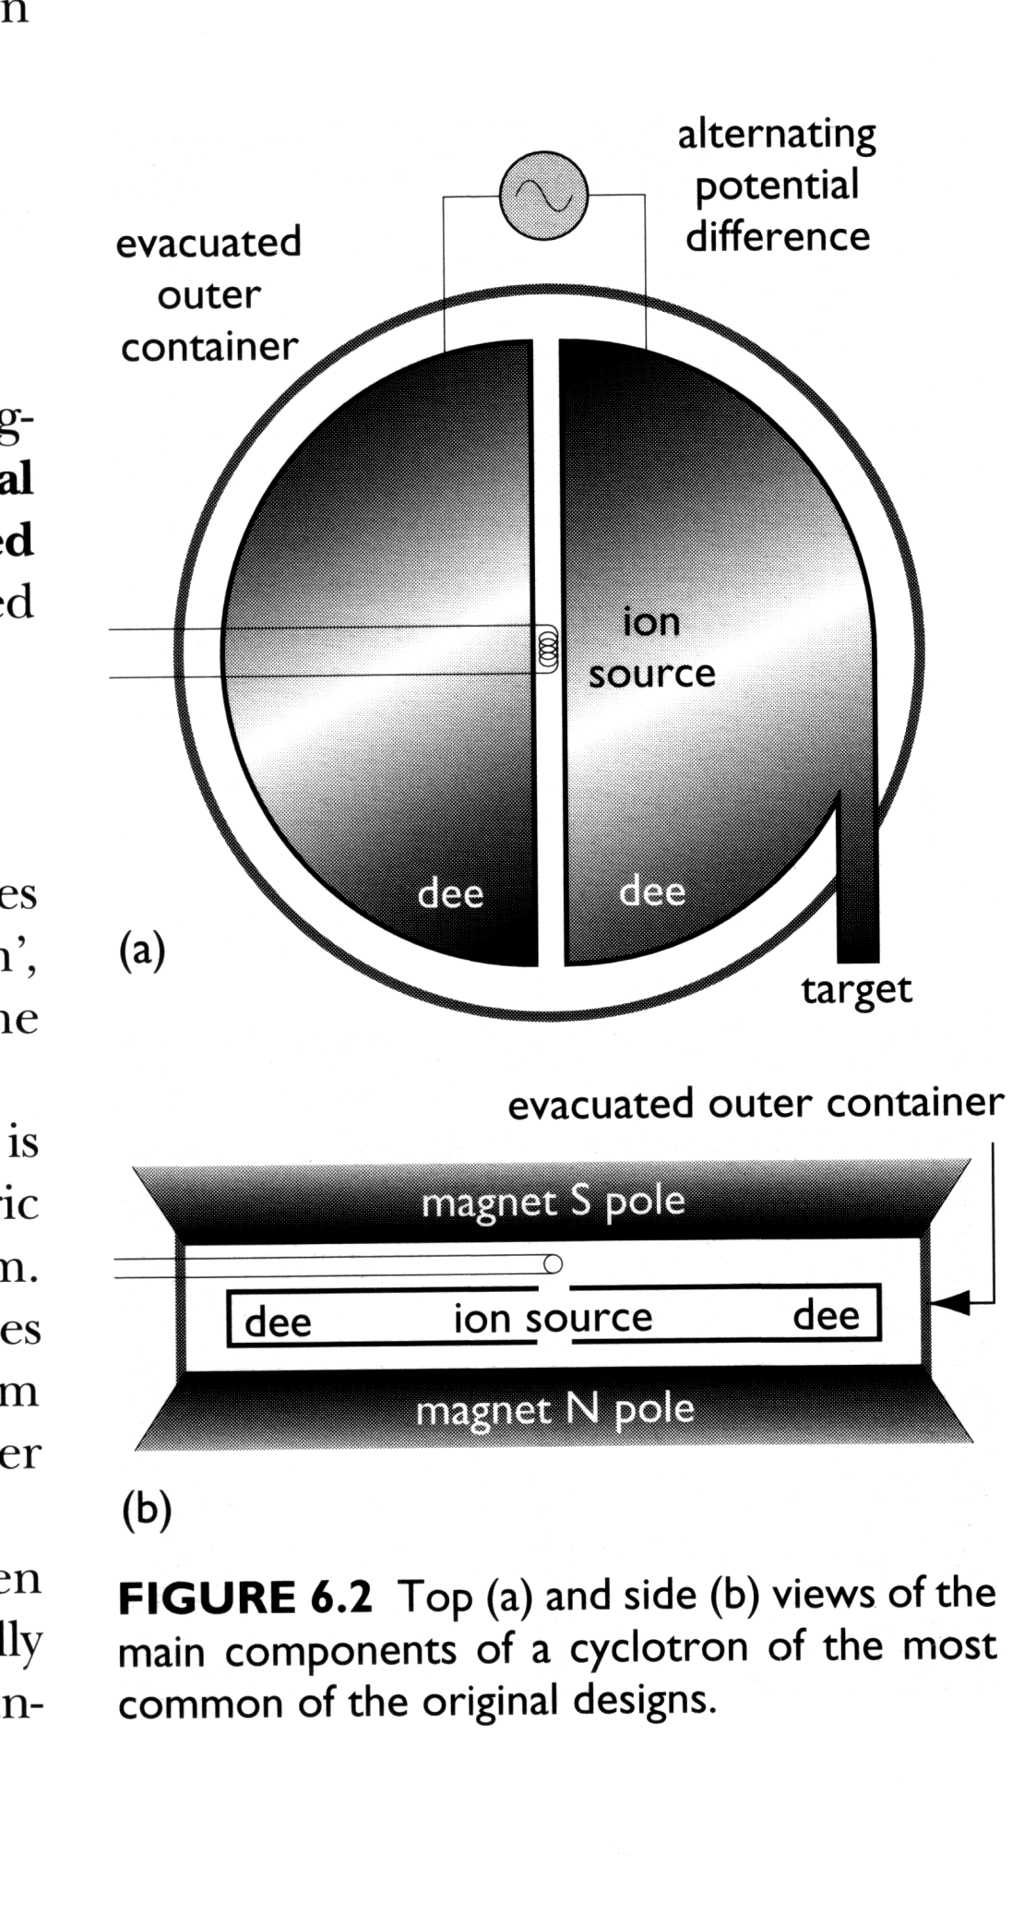
- When a charged particle is moving through a magnetic field region it feels a force that is perpendicular to its direction of motion (and also perpendicular to the magnetic field). Such a force makes the particle change direction but does not change its speed. This means that in a large enough region of magnetic field the particle will travel in a circle. The size of the circle depends on the speed of the particle and the strength of the magnetic field.
Figure 1: Top (a) and side (b) views of the main components of a cyclotron.
Paragraph 3
Now how can we use these two facts to design an accelerator --a cyclotron is one example. We make the region of magnetic field by having a pair of large flat magnets, one above the other, with opposite poles facing, so there is magnetic field pointing down from the lower magnet towards the upper one. We arrange two such regions, each one D-shaped (when looked at from above) with the straight sides of the two D's facing one another (i.e. one D is backwards). Now we have a place where a moving electric charge (or rather a bunch of such charges) goes around half a circle in one D, then goes straight ahead till it reaches the other D, and makes another semicircle in that one, and so on.
Paragraph 4
So now what we have to do is arrange to have an electric field turn on in the right direction (and at the right time) to give the charges a bit of a push each time they cross the gap between the two D's. You can see that the electric field has to reverse its direction while the charge is going around the semicircle inside the D, so that when the charges cross the gap again in the opposite direction they are again accelerated a little.

Paragraph 5
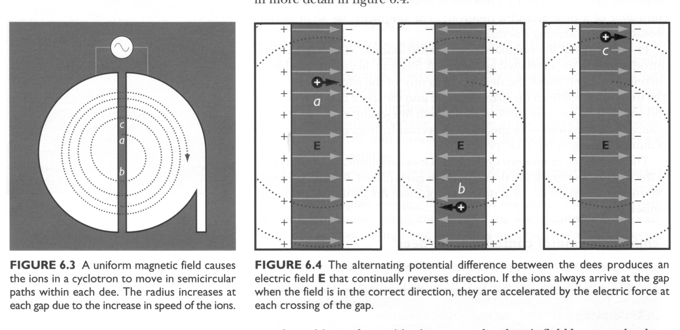
You also need to build a chamber that you can evacuate to very low air pressure in the entire region where your charged particles are traveling -- between the two pairs of D-shaped magnets and in the gap between them. This is because you will keep losing your accelerated particles if they collide with air molecules, so you want as little air (or anything else) as possible inside your accelerator.
Figure 2: A uniform magnetic field causes the ions in a cyclotron to move in semicircular paths within each dee. The radius increases at each gap due to the increase in speed of the ions.
Figure 3: The alternating potential difference between the dees produces an electric field E that continually reverses direction. If the ions always arrive at the gap when the field is in the correct direction, they are accelerated each time they cross the gap.

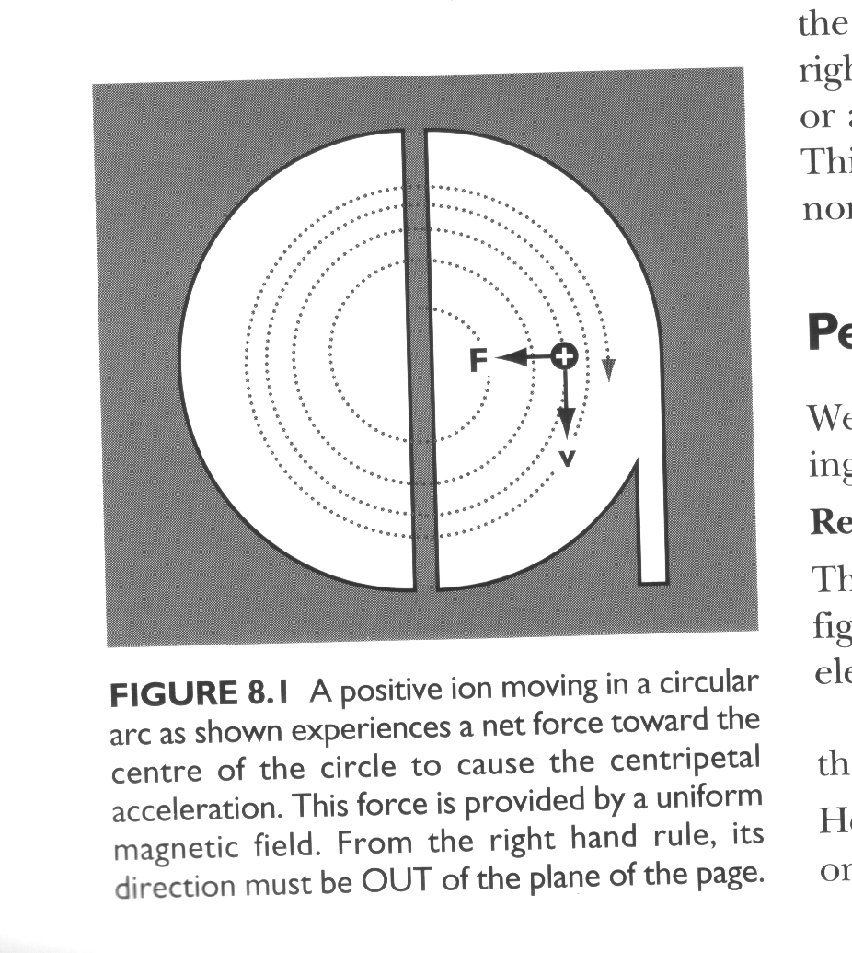
Paragraph 6
Figure 4: A positive ion moving in a circular arc as shown experiences a net force toward the centre of its path. This force is provided by a uniform magnetic field.

Because the particle is speeding up each time it crosses from one D to the other it travels in a spiral path with increasing radius. So the limit on what energy you can get with such a machine is given by the size of the D-shaped magnets, and the vacuum-chamber between them. This limitation makes it very expensive to build a high energy cyclotron and so modern high energy circular accelerators are built using a different design, known as a synchrotron.

Paragraph 7
The basic physics principle is the same, you use magnets to make the particle go in a circle, and regions with electric field in them (usually radio frequency or microwave cavities) to accelerate the particles. You make the vacuum chamber a tube that goes in a circle. Then you must adjust the magnet strength (these are electromagnets) as the particles speed up to keep the same radius for their circular path. There is a limited range of energy over which this can be achieved, so if you look for example at the Fermilab accelerator (see www.fnal.gov) you can see they have a series of rings of increasing radius and then feed the particles from a smaller ring to a larger one once they reach the highest energy that can be made to circulate in the small ring.

Questions

1. Figure 1 shows that an AC current is used to provide the potential difference between the dees of the cyclotron. Why can’t a DC current be used?
[2 marks]

2. Why does the radius of curvature of the charged particle in a cyclotron keep increasing? (paragraph 6)
[2 marks]

3. Explain how a synchrotron differs from a cyclotron? (paragraphs 6 and 7)
[2 marks]

4. Figure 4 shows a positive ion moving in a circular arc. In which direction is the magnetic field? Circle the correct word(s).
[2 marks]
To the left To the right Up

Down Into the page Out of the page
5. A deuteron is an isotope of hydrogen with symbol ²H₁ and a single ion has a mass of 3.34 x 10⁻²⁷ kg and is singly charged. In one cyclotron experiment, a magnetic field of 1.5 T is used and deuterons were extracted at a radius of 25.0 cm. What was the speed of the deuterons when they were extracted?
[4 marks]

6. An early cyclotron had a dee diameter of 24 cm and the oscillating electric field had a frequency of 10.6 MHz .
a) If the frequency of the circular motion of the ions is the same as the electric
field, determine the period of the ion’s circular motion.
b) What magnetic field would be required to achieve this period for a proton?
(hint: a proton is singly charged and its mass is given in the data sheet)

c) How would your answer to (b) have differed for a larger cyclotron?

[8 marks]
END OF SECTION C
END OF EXAMINATION

EdWest Education Year 12 Physics 2005

Suggested Solutions

Section A
- a) Low pitched sound, ∴long wavelength that approximates door width. ∴ diffraction maximised.
b) Assume L = 1.2 m.
λ = 2 x 1.3 = 2.4 m
∴ v = f x λ
= 65.4 x 2.4
= 157 m s⁻¹
- Assume end of barrel is 10 cm above ground
For y dir’n
V_{y} = 1.5 sin 32º
= 0.79488 m s⁻¹
s = ut + ½ at²
-0.1 = 0.79488t + ½ (-9.81)t²
∴ t = 0.245 s
For x dir’n
s_{x} = u_{x} x t
= (1.5cos32º) x 0.245
= 0.312 m
- Crane A would be more stable as the centre of mass is well within its wide base. Crane B has a much smaller base and its centre of mass would not have to shift far for it to be outside the base and cause the crane to topple.

 Time of flight
✓ Initial velocity
 Net force during flight
 Net acceleration during flight
✓ Final (impact) velocity
✓ Final horizontal displacement
 Final vertical displacement
- When some minerals absorb uv light, their electrons are promoted to higher levels. When these electrons return to the ground state, they often do so via a series of smaller steps that may emit photons of visible light. Therefore by illuminating a fluorescent gem with uv light, it appears to ‘glow’ visible light.
- a) 6th harmonic
b) 6 x ½ λ = 0.75 cm
∴ λ = 0.25 cm
f = v/λ
= 346/0.25
= 138 Hz
- This observation is explained by resonance. Tape recorder plays back at the natural frequency of the tuning fork, ∴stimulating the fork at its natural frequency. ∴causing the tuning fork to vibrate at its natural frequency and make a sound.
- Assume r = 0.2 m
want a_{c} >= g
∴ v²/r >= 9.81 m s⁻¹
∴ v >= 1.40 m s⁻¹
- a) I = P/V
= 80 x 10³/450
= 1.78 x 10³ A
b) n_{p}/n_{s} = V_{p}/V_{s}
= 130 000/450
= 289
ie: 289:1
- Sodium lamp produces a line spectrum only. This is caused by a high potential difference exciting electrons to high levels and upon returning to the ground state, photons of yellow light are emitted.
The candle produces a continuous spectrum with a few lines due to specific elements present in the wax. This is caused by incandescence, where a hot object emits a variety of photons, the energy of which depends on the temperature of the object.
- a) Assume: length = 30 cm
distance between nail and pivot point = 5 cm
Hammer claws are perpendicular to nail
ΣCWM = ΣACM
120 x 0.3 = F x 0.05
∴ F = 7.20 x 10³ N
b) Claws of hammer are perpendicular to nail, maximising the force in the direction of the nail, this will prevent nail from bending and make it easier to remove.
Also pivot point is closer to nail, smaller ‘r’ results in larger ‘F’ (M= rF)
- E = F/A
ΔL/L
2.10 x 10¹¹ = 120 x 10³/(π x 0.05²)
ΔL/0.33
∴ ΔL = 2.40 x 10⁻³ m (2.40 mm)
- eg: Arrange bars as below:
This technique will successfully identify the magnetised bar.
N
N
S
S
Limited attraction.
Strong attraction.
- a) DC. Would produce a constant magnetic field in the coil, to apply a torque in a constant direction. AC would simply cause the needle to oscillate.
b) When a current is present in the coil, a magnetic field is induced and this interacts with the external magnetic field. This causes the armature and pointer to turn and try to align the two fields against the force of the spring. The larger the current, the more movement is produced and this movement can be calibrated to measure the current flowing.
- Blue. Photons blue light are more energetic (E = hf) as they are of a higher frequency than photons of red light

Section B
- a) 2 T cos 30º = 225 x 9.81
∴ T = 1 270 N
b) Take moments about pivot:
ΣCM = ΣACM
2210 x 5.5 x sin70º + 1230 x 2.75 x sin 70º = F_{R} x 2.5 x sin30º
∴ F_{R} = 1.16 x 10⁴ N
c) Horizontal distance from CoM of beam to rear wheels of crane:
Taking moments about rear wheels of crane:
Distance from rear wheel to line of action of weight of boom
= 4.50 – (5.5/2 x cos 20⁰)
= 1.92 m
ΣCM = ΣACM
(L x 9.81 x 4.5) + (125 x 9.81 x 1.92) = 5.6 x 10³ x 9.81 x (2.5 – 0.75)
∴ L = 2.12 x 10³ kg
d)
* Raise boom. This will decrease horizontal distance from rear wheels to load, ∴ decrease the CW moment caused by the load.
* Shorten the boom. This will decrease horizontal distance from rear wheels to load, ∴ decrease the CW moment caused by the load.
* Install ‘outriggers’ at rear of crane. This will shift the pivot point closer to the load and further from the counter-mass. ∴ reduce moment caused by load and increase moment caused by mass of crane.
e) Breaking stress = 11.0 x 10⁸ Pa
σ = F/A
11.0 x 10⁸ = 2.12 x 10³ x 9.81/A
∴ A = 1.89 x 10⁻⁵ m
∴ πr² = 1.89 x 10⁻⁵ m
∴ r = 2.45 x 10⁻³ m
∴ d = 4.90 x 10⁻³ m
f) (c): No difference as both CW and ACM would both be less
(e): Thinner cable possible as less stress due to smaller weight.

- a) i)
15º
T
W
F_{net}

ii) ΣF_{y} = 0
mg = 0.15 x g x sin 15º
= 3.88 x 10⁻² kg
iii) Tcos 15º = mv²/r
0.15 x 9.81 x cos 15º = 3.88 x 10⁻² x v²/0.33cos 15º
∴ v = 3.42 m s⁻¹
iv) Shorter. Tension would be greater due to increased gravity. As T α 1/r (T=mv²/r), r becomes smaller as T becomes greater.
b) i) E = hf
= 6.63 x 10⁻³⁴ x 3.00 x 10⁸/514 x 10⁻⁹
= 3.87 x 10⁻¹⁹ J
ii) Power of 514 nm photons emitted = 99.9/100 x 1.33 = 1.3287 W
ie: 1.3287 Joules per second.
∴ No of photons = 1.3287/3.87 x 10⁻¹⁹
= 3.43 x 10¹⁸
iii) 3.87 x 10⁻¹⁹ J = 2.42 eV

- a) i) D
ii) BiL = ma
a = 4.0 x 10⁻² x 16.0 x 4.0 x 10⁻²/55 x 10⁻³
= 0.465 m s⁻²
iii) Friction between wheels and rail
Movement of axle induces a current, the field of which opposes the direction of motion – Lenz’s law.
b) i) Vertical
ii) B_{v} = 2.0 x 10⁻⁴ x sin60º
= 1.73 x 10⁻⁴ T
iii) emf = 1.73 x 10⁻⁴ x 10 x 200
= 0.346 V
iv) No. Any wiring used to make a complete circuit will also cut flux and induce an emf. ∴ no net emf.
v)
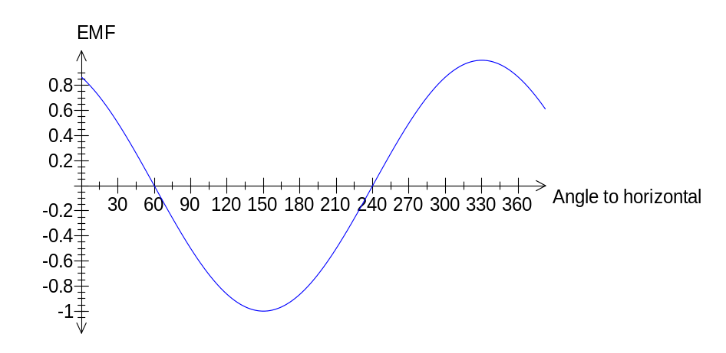

- a) i) Destructive interference. Sound from the two speakers is arriving ½ λ out of phase.
ii)
λ/2 = d₂ – d₁
= √(1.85² + 8²) - √(1.15² + 8²)
∴ λ = 0.25784 m
∴ f = 346/0.25784
= 1340 Hz
3.0 m
8.0 m
d₁
d₂
1.15 m
1.85 m
iii) Constant tone as it is an antinodal line. Would get louder as she approached the speakers.
iv) She would have experienced destructive interference originally (quiet) and constructive interference (loud) when she moved her head.
- a) i) g = GM/r²
= 6.67 x 10⁻¹¹ x 1.35 x 10²³/(2575 x 10³)²
= 1.36 m s⁻²
ii) GM_{s}M_{T}/r² = M_{T}v²/r
∴ M_{s} = v²r/G
= (5.57 x 10³)² x 1221850 x 10³/6.67 x 10⁻¹¹
= 5.70 x 10²⁶ kg
b) Want period of 15.95 x 14 x 60 x 60 = 1.378 x 10⁶ s
r³ = GM_{T}T²/4π²
∴ r = 7.57 x 10⁷ m
∴ altitude = 7.57 x 10⁷ – 2.575 x 10⁶
= 7.31 x 10⁷m
c)
i) Will assume a_{c} = g (ie: 250 m altitude would have negligible effect on gravity strength).
v²/r = g
v² = 1.36 x 2.575 x 10⁶
∴ v = 1.87 x 10³ m s⁻¹
ii) No. Kit would be moving so fast that it would be destroyed on impact.
iii) If she was travelling any slower at that altitude, she would need to use her thrusters to maintain altitude and not crash. This would use fuel.
iv) No. Air resistance would cause ship to decelerate and ultimately lose altitude and crash, ∴ such a low orbit would not be possible. Also at such a speed, the spaceship may ‘burn up’.
- a) i) 41º. As plate is fully immersed, the whole time, there is no change in flux, ∴ no induced emf and no retarding force.
ii) Would not swing as high due to the eddy currents induced by the magnetic field reversing. These eddy currents have a field that oppose the external field (Lenz’s law) and retard the motion. Therefore it would make an angle greater than 41º with the horizontal.
iii) (i): no change
(ii): less retardation as smaller eddy currents induced. Would swing higher.
b) i) 1.0 x 10⁻¹² W m⁻²
ii) Assume: Sound travels spherically and no sound energy is lost.
P = I x A
= 10⁻¹² x 4π(10)²
= 1.26 x 10⁻⁹ W
iii) I = P/A
= 1.26 x 10⁻⁹/4π(0.1)²
= 1.00 x 10⁻⁸ W m⁻²
∴ L = 10 log (I/10⁻¹²)
= 10 log (10⁻⁸/10⁻¹²)
= 4.00 x 10¹ dB
iv) No of mozzies = 10⁻⁸/10⁻¹²
= 1.00 x 10⁴ (10 000 - ouch!)

Section C

Passage 1
- No. It is not fluorescence as the web is reflecting the uv light not absorbing it and re-emitting it as visible light. (Although possibly high frequency uv is absorbed and lower frequency uv is re-emitted which is visible to insects but not to us.)
- The radial threads don’t have the sticky watery glue which causes the threads to bunch up and allow the ‘give’ of the spiral threads.
- Radial threads are responsible for transmitting the vibrations of captured insects to the spider. The stiff threads are best for this purpose as the stiffer the material, the faster the vibrations are transferred. This is illustrated by the difference in the speed of sound between solids and liquids.

Property | Type of thread (R or S)
Made sticky with a watery glue | S
Stiffest | R
Most elastic | S
Lowest Young’s Modulus value | S
Best at transmitting vibrations | R

- stress/strain = 1.1 x 10^{9/}/0.19 = 5.79 x 10⁹ Pa. This value is less that the Young’s modulus value, indicating that the thread was behaving plastically.
Passage 2
- The current needs to constantly reverse direction so that the particle is always accelerated as it passes between the dees. If it was DC, it would accelerate in one direction and decelerate in the other.
- Because it is gaining velocity each time it passes between the dees. F_{c}=mv²/r. ∴ v² α r. ie: the radius of curvature increases with increased velocity.

- In a synchrotron the magnetic field increases in strength so that the centripetal force applied is strong enough to keep the particles in a constant radius circle, even though they are constantly speeding up. In a cyclotron he radius of curvature increases until the particle exits.
- Out of the page
- Bvq = mv²/r
1.5 x v x 1.6 x 10⁻¹⁹ = 3.34 x 10⁻²⁷ x v²/0.25
∴ v = 1.79 x 10⁷ m s⁻¹
- a) T = 1/f
= 1/10.6 x 10⁶
= 9.43 x 10⁻⁸ s
b) v = 2πr/T
= 2π(0.24)/9.43 x 10⁻⁸
= 1.59 x 10⁷ m s⁻¹
Bvq = mv²/r
B = mv/rq
= 1.67 x 10⁻²⁷ x 1.59 x 10⁷/0.24 x 1.6 x 10⁻¹⁹
= 0.695 T
c) B would have been smaller as the radius of curvature would be greater. B α 1/r
END OF SOLUTIONS

